**Nama : Fikri Fikrul Mubarok**

**NIM : 1127050059**

**Kelas : IF / V / G**

**Quis 2 Praktikum RPLL**

**Kode Soal : IF4**

1. Use Case Diagram

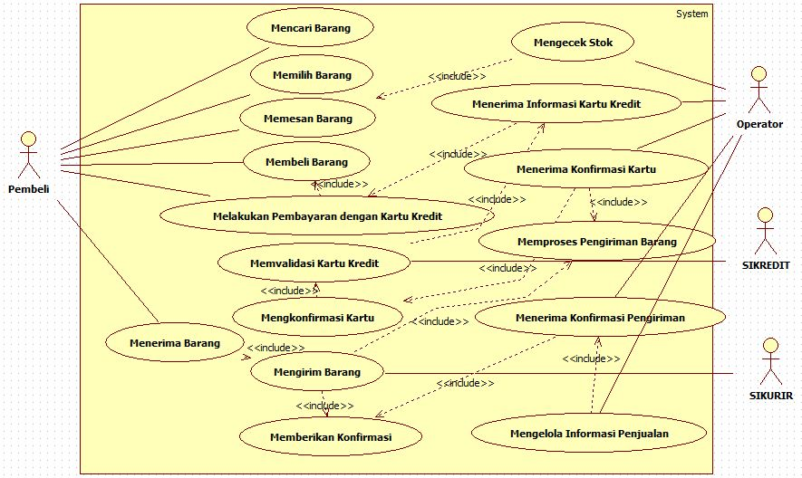

1. Class Diagram

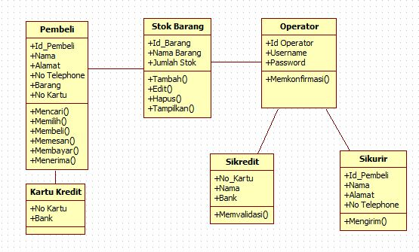

1. Squence Diagram
2. Mencari Barang

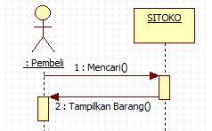

1. Memilih Barang

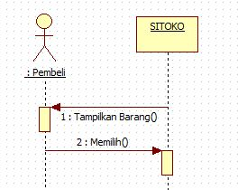

1. Memesan Barang

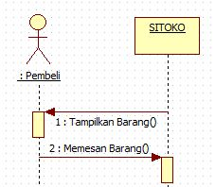

1. Mengecek Stok

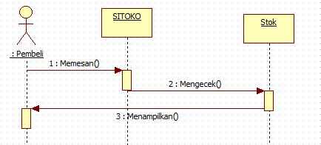

1. Membeli Barang

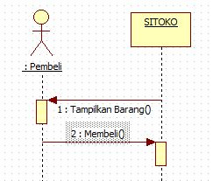

1. Membayar

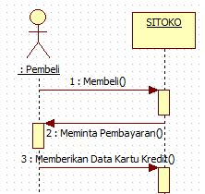

1. Memvalidasi

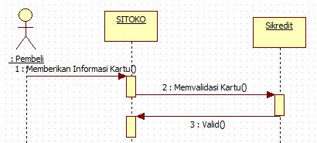

1. Mengirim Barang

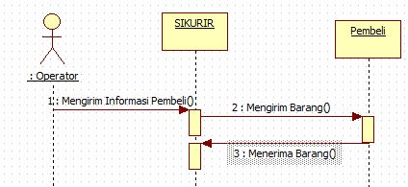

1. Collaboration Diagram

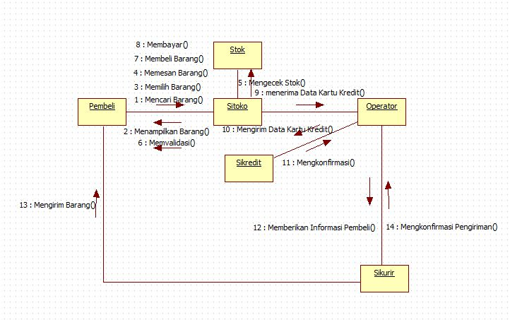

1. State Diagram

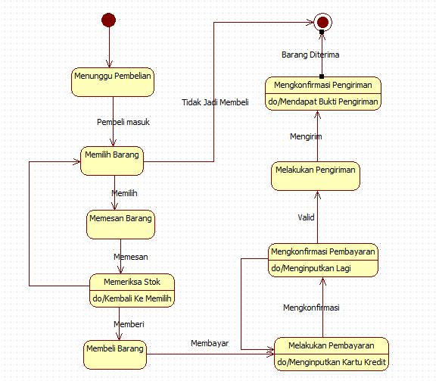

1. Activity Diagram

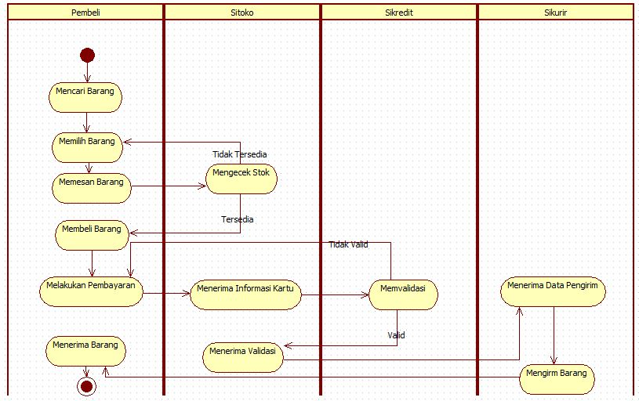

1. Component Diagram

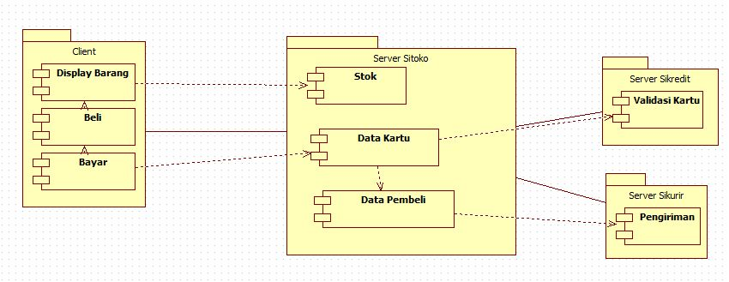

1. Deployment Diagram

